Mr. Sabado, Algebra 1 Week 10 Monday, November 3, 2014

Homework

Due Today:
- Assignment #39:
“What do you get when you…” Handout

Due 11/4:
- Assignment #40:
-Solving Equations p. 32 & 28

Quiz Friday!!!

Agenda

- Pick Opener Sheet
- Warm-Up
- HW Questions
- Seating Chart

- Lesson: Solving Equations with Variables on both sides

- Class Work
- Homework
- Return Graded Work



Warm-Up

Solve

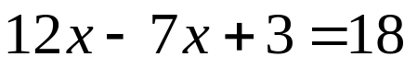

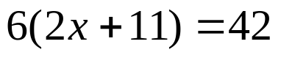


whs.saba.do

“It is never too late to be what you might have been.”
- G. Eliot

