Mr. Sabado, Algebra 2 Week 8 Tuesday, March 14, 2017

Home Practice

Due Today:
Assignment #31:
p. 519 (3-23 odd, 56-58)

Due 3/15:
Assignment #32:
p. 520 (25-43 odd, 44, 46)

Quiz on Friday!!!

**Unit Test**
3/22 → Calculator
& 3/23 → No Calculator

Agenda

- Warm-Up
- HW Questions

- Lesson: Solving Logarithm Equations

- Class Work
- Homework
- Return Graded Work

Warm-Up

Simplify
1) 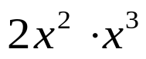
2) 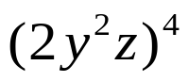
3) 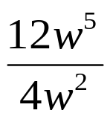



“It is never too late to be what you might have been.”
- G. Eliot

