Mr. Sabado, Algebra 2 Week 8 Wednesday, March 15, 2017

Home Practice

Due Today:
Assignment #32:
p. 520 (25-43 odd, 44, 46)

Due 3/16:
Assignment #33:
7.4-7.5 Review

Quiz on Friday!!!

**Unit Test**
3/22 → Calculator
& 3/23 → No Calculator

Agenda

- Warm-Up
- HW Questions

- Review: Exponential and Log Functions

- Class Work

- Homework

- Return Graded Work

Warm-Up

Evaluate the logs
1) 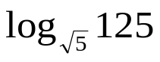

2) 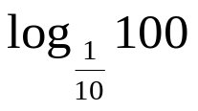

3. Solve



“It is never too late to be what you might have been.”
- G. Eliot

