Mr. Sabado, Algebra 2 Week 8 Thursday, March 16, 2017

Home Practice

Due Today:
Assignment #33:
7.4-7.5 Review

Due 3/16:
Assignment #34:
Unit 6 Solving Practice

Quiz on Friday!!!

**Unit Test**
3/22 → Calculator
& 3/23 → No Calculator

Agenda

- Seating Chart
- Warm-Up
- HW Questions

- Review: Condensing and Expanding Expressions

- Class Work

- Homework

- Return Graded Work

Warm-Up

Evaluate without a calculator.
1) 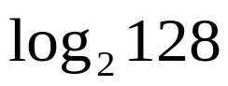
2) 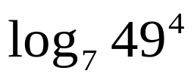
3)Solve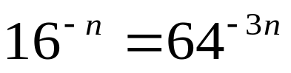


“It is never too late to be what you might have been.”
- G. Eliot

