Mr. Sabado, Pre-Algebra Week 11 Monday, April 21, 2014

Home Practice

Due Today:
- No Home Practice

Due 4/22:
- Assignment #36: Functions Review Worksheet



Agenda

- Opener Sheet

- Warm-Up

- Class Practice: What did Farmer John…

- Home Practice

- Return Graded Work

Warm-Up

- Is x = 12 a solution to the equation 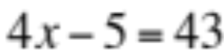

- Solve the proportion
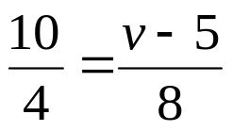

whs.saba.do

“It is never too late to be what you might have been.”
- G. Eliot

