Mr. Sabado, Pre-Algebra Week 11 Tuesday, April 22, 2014

Home Practice

Due Today:
- Assignment #36: Functions Review Worksheet

Due 4/23:
- Assignment #37:
Page 408: 2-34 Even



Agenda

- Warm-Up

- Lesson: Point Test and Graphing

- Class Practice

- Home Practice

- Return Graded Work

Warm-Up

- Is x = 1 a solution to the equation 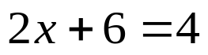

- Solve the proportion
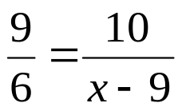

whs.saba.do

“It is never too late to be what you might have been.”
- G. Eliot

