Mr. Sabado, Pre-Algebra Week 11 Wednesday, April 23, 2014

Home Practice

Due Today:
- Assignment #37:
Page 408: 2-34 Even

Due 4/24:
- Assignment #38:
Equations with 2 Variables Handout



Agenda

- Warm-Up

- Lesson: Horizontal and Vertical Lines

- Class Practice

- Home Practice

- Return Graded Work

Warm-Up

- Is (-2, 4) a solution to the equation 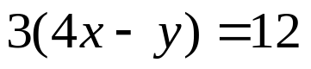
- Solve the proportion
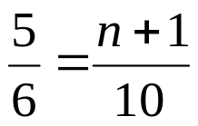

whs.saba.do

“It is never too late to be what you might have been.”
- G. Eliot

