Mr. Sabado, Pre-Algebra Week 11 Thursday, April 24, 2014

Home Practice

Due Today:
- Assignment #38:
Equations with 2 Variables Handout

Due 4/25:
- Assignment #39:
Quiz Review Handout

Quiz Tomorrow!!!

Agenda

- Warm-Up
- HP Check

- Review: Horizontal Lines, Vertical Lines, and Isolating “y”

- Elbow Partner: Class Work
- Homework
- Return Graded Work

Warm-Up

- Make a T-Table and Graph the following linear equation 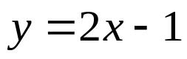

- Isolate the y-variable
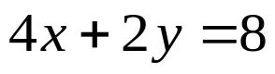

whs.saba.do

“It is never too late to be what you might have been.”
- G. Eliot

