Mr. Sabado, Pre-Algebra Week 11 Friday, April 25, 2014

Home Practice

Due Today:
- Assignment #39:
Quiz Review Handout
- Opener Packet

Due 4/28:
Extra Credit Handout

Quiz Today!!!



Agenda

- Warm-Up
- Turn in Opener Packet

- Quiz: Horizontal Lines, Vertical Lines, and Isolating “y”

- Quiet Activity

- Return Graded Work

Warm-Up

- Make a T-Table and Graph the following linear equation 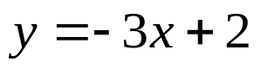

- Isolate the y-variable
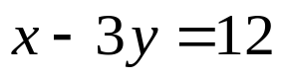

whs.saba.do

“It is never too late to be what you might have been.”
- G. Eliot

