Mr. Sabado, Pre-Algebra Week 12 Monday, April 28, 2014

Home Practice

Due Today:
Extra Credit Handout

Due 4/29:
Assignment #40: Finding the Slope of a Line

Quiz Friday!!!



Agenda

- New Opener Sheet
- Warm-Up
- Grade Quiz

- Lesson: Slope

- Class Practice

- Home Practice

- Return Graded Work

Warm-Up

- Isolate the y-variable
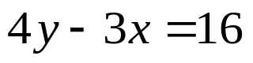

2. Solve
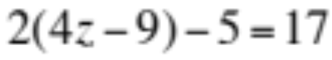

whs.saba.do

“It is never too late to be what you might have been.”
- G. Eliot

