Mr. Sabado, Pre-Algebra Week 12 Tuesday, April 29, 2014

Home Practice

Due Today:
Assignment #40: Finding the Slope of a Line

Due 4/30:
Assignment #41: Finding the Slope of a Line

Quiz Friday!!!


Agenda

- Warm-Up
- HP Check

- Review: Slope

- Class Practice

- Home Practice

- Return Graded Work

Warm-Up

Use the following formula to find the slope.
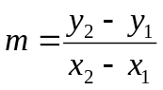

1. 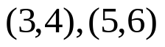

2. 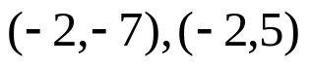

whs.saba.do

“It is never too late to be what you might have been.”
- G. Eliot

