Mr. Sabado, Pre-Algebra Week 12 Wednesday, April 30, 2014

Home Practice

Due Today:
Assignment #41: Finding the Slope of a Line

Due 5/1:
Assignment #42: Finding the Slope and Y-Intercept

Quiz Friday!!!


Agenda

- Warm-Up
- HP Check

- Review: Slope and Graphing

- Math Sprint Class Practice

- Home Practice

- Return Graded Work

Warm-Up

Use the following formula to find the slope.
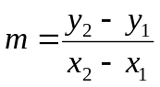
1. 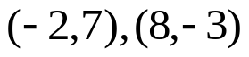

2. Isolate the Y-Variable 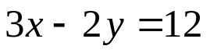

whs.saba.do

“It is never too late to be what you might have been.”
- G. Eliot

