Mr. Sabado, Pre-Algebra Week 12 Thursday, May 1, 2014

Home Practice

Due Today:
Assignment #42: Finding the Slope and Y-Intercept

Due 5/2:
Assignment #43:
Quiz Review Worksheet
Opener Packet

Quiz Friday!!!


Agenda

- Warm-Up
- HP Check

- Lesson: Slope-Intercept Form

- Exit Ticket

- Home Practice

- Return Graded Work

Warm-Up

Use the following formula to find the slope.
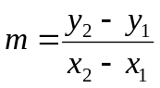
1. 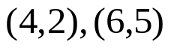

Find the slope and y intercept of the following.
2.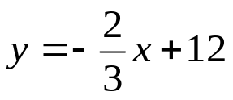

whs.saba.do

“It is never too late to be what you might have been.”
- G. Eliot

