Mr. Sabado, Pre-Algebra Week 14 Monday, May 12, 2014

Home Practice

Due Today:
- E.C.:
Whom should you see at the bank…

Due 5/13:
- Assignment #49
Chapter 8 Review #1

Chapter 8 Test Friday!!!

Agenda

- Opener Sheet
- Warm-Up

- Review: Graphing with Slope and Intercept

- Class Practice

- Home Practice

- Return Graded Work

Warm-Up
- Solve the following inequality.
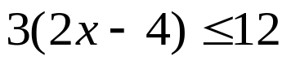

2. Isolate the y-variable
4x + 2y > 10



“It is never too late to be what you might have been.”
- G. Eliot

