Mr. Sabado, Pre-Algebra Week 14 Tuesday, May 13, 2014

Home Practice

Due Today:
- Assignment #49
Chapter 8 Review #1

Due 5/14:
- Assignment #50
Chapter 8 Review #2

Chapter 8 Test Friday!!!

Agenda

- Warm-Up
- HP Check

- Lesson: Graphing Linear Inequalities

- Class Practice

- Home Practice

- Return Graded Work

Warm-Up
1. Solve
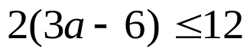

2. 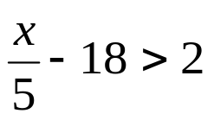



“It is never too late to be what you might have been.”
- G. Eliot

