Mr. Sabado, Pre-Algebra Week 14 Wednesday, May 14, 2014

Home Practice

Due Today:
- Assignment #50
Chapter 8 Review #2

Due 5/15:
- Assignment #51
Chapter 8 Review #3

Chapter 8 Test Friday!!!

Agenda

- Warm-Up

- Review: Graphing Linear Inequalities

- Class Practice

- Home Practice

- Return Graded Work

Warm-Up
- Isolate the y-variable
3x + 4y > 16

- Graph the inequality.
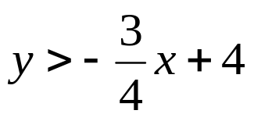



“It is never too late to be what you might have been.”
- G. Eliot

