Mr. Sabado, Pre-Algebra Week 14 Thursday, May 15, 2014

Home Practice

Due Today:
- Assignment #51
Chapter 8 Review #3

Due 5/16:
- Assignment #52
Chapter 8 Review #4
Opener Packet

Chapter 8 Test Friday!!!

Agenda

- Warm-Up
- HP Check

- Review: Graphing Linear Inequalities

- Class Practice

- Home Practice

- Note Card
- Return Graded Work

Warm-Up

Use the following formula to find the slope.
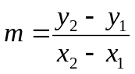
- 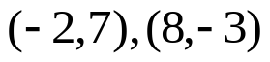

Graph the following linear inequality.
2.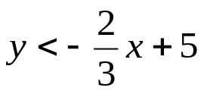


“It is never too late to be what you might have been.”
- G. Eliot

