Mr. Sabado, Pre-Algebra Week 14 Friday, May 16, 2014

Home Practice

Due Today:
- Assignment #52
Chapter 8 Review #4
Opener Packet

Due 5/19:
- No HP

Chapter 8 Test Today!!!

Agenda

- Warm-Up
- HP Check
- Last Questions

- Turn in Opener Packet

- Chapter 8 Test:

- Quiet Activity

- Return Graded Work

Warm-Up

Use the following formula to find the slope.
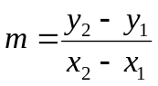
1) 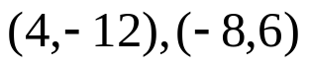

Isolate the y-variable
2. 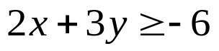



“It is never too late to be what you might have been.”
- G. Eliot

