Mr. Sabado, Pre-Algebra Week 15 Monday, May 19, 2014

Home Practice

Due Today:
- No HP

Due 5/20:
- Assignment #53
- Section 10-1 and Review

Quiz on Friday!!!

Agenda

- Warm-Up
- Seating Chart

- Lesson: Area of Parallelograms

- Home Practice

- Door Check

- Return Graded Work

Warm-Up
Simplify
- 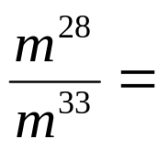

- Simplify
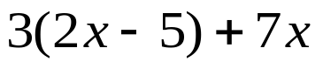


“It is never too late to be what you might have been.”
- G. Eliot

