Mr. Sabado, Pre-Algebra Week 12 Friday, May 2, 2014

Home Practice

Due Today:
Assignment #43:
Quiz Review Worksheet
Opener Packet

Due 5/5:
Assignment #44:
What might you have…

Quiz Today!!!


Agenda

- Warm-Up
- HP Check
- Turn in Opener Packet

- Quiz #8: Slope-Intercept Form

- Quiet Activity

- Home Practice

- Return Graded Work

Warm-Up

Use the following formula to find the slope.
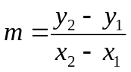
1. 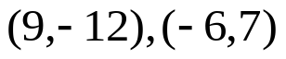

2. Write an equation in Slope-Intercept Form with m = 3 and b= -5

whs.saba.do

“It is never too late to be what you might have been.”
- G. Eliot

