Mr. Sabado, Pre-Algebra Week 15 Tuesday, May 20, 2014

Home Practice

Due Today:
- Assignment #53
- Section 10-1 and Review

Due 5/21:
- Assignment #54
- P. 524: 1-18

Quiz on Friday!!!

Agenda

- Warm-Up
- HP Check

- Review: Area of Parallelograms

- Elbow Partner Class Practice

- Home Practice

- Return Graded Work

Warm-Up
Find the area of

3.5 in.

12 in.

Solve the proportion
2. 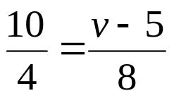



“It is never too late to be what you might have been.”
- G. Eliot

