Mr. Sabado, Pre-Algebra Week 15 Wednesday, May 21, 2014

Home Practice

Due Today:
- Assignment #54
- P. 524: 1-18

Due 5/22:
- Assignment #54
- P. 530: 1-16, 24, 25

Quiz on Friday!!!


Agenda

- Warm-Up
- HP Check

- Lesson: Area of Triangles and Trapezoids

- Class Practice

- Home Practice

- Return Graded Work

Warm-Up
Simplify
- 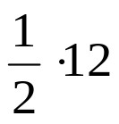

- 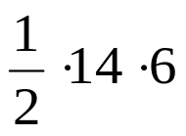

- 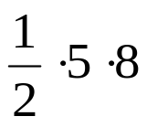

“It is never too late to be what you might have been.”
- G. Eliot

