Mr. Sabado, Pre-Algebra Week 15 Friday, May 23, 2014

Warm-Up

Use the following formula to find the slope. 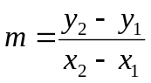
1. 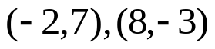



Home Practice

Due Today:
- Assignment #56
- Areas of Tri’s and Quad’s
- Opener Packet

Due 5/27:
- No HP

Quiz Today!!!


Agenda

- Warm-Up
- Turn in Opener Packet

- Quiz: Area of Triangles and Trapezoids

- Quiet Activity Home Practice

- Return Graded Work

“It is never too late to be what you might have been.”
- G. Eliot

