Mr. Sabado, Pre-Algebra Week 16 Tuesday, May 27, 2014

Warm-Up

Simplify the following.
- 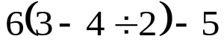

- 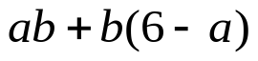
when a = 2, b = -3



Home Practice

Due Today:
- No HP

Due 5/28:
- Assignment #57
- Chapter 10-1 and 10-2

Quiz Today!!!


Agenda

- New Opener Sheet
- Warm-Up

- Review: Parallelograms, Triangles, and Trapezoids

- Class Practice
- Home Practice

- Return Graded Work

“It is never too late to be what you might have been.”
- G. Eliot

