Mr. Sabado, Pre-Algebra Week 16 Wednesday, May 28, 2014

Warm-Up

Simplify the following.
- 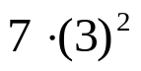

- 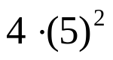



Home Practice

Due Today:
- Assignment #57
- Chapter 10-1 and 10-2

Due 5/29:
- Assignment #58
Page 535: 1-17

Quiz Friday!!!


Agenda

- Warm-Up
- HP Check

- Lesson: Circles

- Class Practice

- Home Practice

- Return Graded Work

“It is never too late to be what you might have been.”
- G. Eliot

