Mr. Sabado, Pre-Algebra Week 16 Thursday, May 29, 2014

Warm-Up

- What is the formula to find the area of a trapezoid?

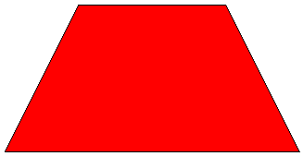



Home Practice

Due Today:
- Assignment #58
Page 535: 1-17

Due 5/30:
- Assignment #59
Areas of Circles + Quiz Review
- Opener Packet

Quiz Friday!!!


Agenda

- Warm-Up
- HP Check

- Review: Circles

- Class Practice

- Home Practice

- Return Graded Work

“It is never too late to be what you might have been.”
- G. Eliot

