Mr. Sabado, Pre-Algebra Week 16 Friday, May 30, 2014

Warm-Up
- Find the area of the circle.

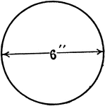


Home Practice

Due Today:
- Assignment #59
Areas of Circles + Quiz Review
- Opener Packet

Due 6/2:
- Extra Credit: 10-2 Enrichment

Quiz Today!!!


Agenda

- Warm-Up
- HP Check
Turn in Opener Packet

- Quiz: Areas of Circles, Triangles, and Quadrilaterals

- Quiet Activity
- Home Practice

- Return Graded Work

“It is never too late to be what you might have been.”
- G. Eliot

