Mr. Sabado, Pre-Algebra Week 13 Monday, May 5, 2014

Home Practice

Due Today:
Assignment #44:
What might you have…

Due 5/6:
Assignment #45:
What might you have…

Quiz Friday!!!


Agenda

- Opener Sheet
- Warm-Up

- Lesson: Graphing with Slope and Intercept

- Class Practice

- Home Practice

- Return Graded Work

Warm-Up

Use the following formula to find the slope.
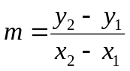
- 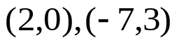

2. Isolate the y-variable
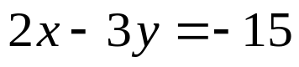

whs.saba.do

“It is never too late to be what you might have been.”
- G. Eliot

