Mr. Sabado, Pre-Algebra Week 13 Tuesday, May 6, 2014

Home Practice

Due Today:
Assignment #45:
Graphing Lines

Due 5/7:
Assignment #46
Graphing Linear Equations

Quiz Friday!!!


Agenda

- Warm-Up

- Review: Graphing with Slope and Intercept

- Class Practice

- Exit Ticket

- Home Practice

- Return Graded Work

Warm-Up

1. Isolate the y-variable
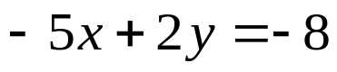

2. Determine the slope and y-intercept
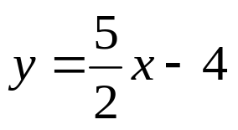
whs.saba.do

“It is never too late to be what you might have been.”
- G. Eliot

