Mr. Sabado, Pre-Algebra Week 13 Wednesday, May 7, 2014

Home Practice

Due Today:
Assignment #46
Graphing Linear Equations Handout

Due 5/8:
Assignment #47
Graphing Linear Systems

Quiz Friday!!!


Agenda

- Warm-Up

- Lesson: Graphing Linear Systems

- Exit Ticket

- Home Practice

- Return Graded Work

Warm-Up

Graph the following linear equations on the same graph.
1.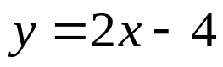

2. 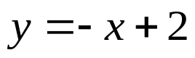
whs.saba.do

“It is never too late to be what you might have been.”
- G. Eliot

