Mr. Sabado, Pre-Algebra Week 13 Thursday, May 8, 2014

Home Practice

Due Today:
Assignment #47
Graphing Linear Systems

Due 5/9:
- Assignment #48
Quiz Review Packet
- Opener Packet

Quiz Friday!!!


Agenda

- Warm-Up

- Review: Graphing Linear Systems

- Class Work

- Homework

- Return Graded Work

Warm-Up

Graph the following linear equations on the same graph.
1.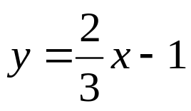
2. 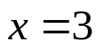

3. Is the point (-3, 1) a solution to the system?
x + y = -2
x + 6y = 3

“It is never too late to be what you might have been.”
- G. Eliot

