Mr. Sabado, Pre-Algebra Week 13 Friday, May 9, 2014

Home Practice

Due Today:
- Assignment #48
Quiz Review Packet
- Opener Packet

Due 5/13:
- E.C.:
Whom should you see at the bank…

Quiz Today!!!


Agenda

- Warm-Up
- Turn in Opener Packet

- Quiz: Graphing Linear Systems

- Quiet Activity

- Extra Credit

- Return Graded Work

Warm-Up
- Graph and find the intersection.
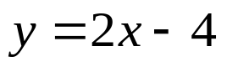
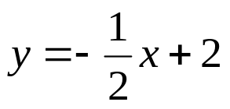

2. Is the point (6, -2) a solution to the system?
2x + y = 10
3x + 6y = 3

“It is never too late to be what you might have been.”
- G. Eliot

