Mr. Sabado, Pre-Algebra Week 18 Tuesday, June 10, 2014

Warm-Up

Write the prime factorization for the following (hint: use a factor tree)
- 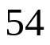

Simplify the following.
- 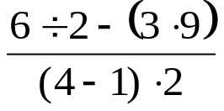


Home Practice

Due Today:
- Assignment #64
- Chapter 3 Cumulative Review

Due 6/11:
- Assignment #65
- Chapter 4 Cumulative Review

Quiz on Friday!!! 

Agenda

- Warm-Up
- HP Check

- Review: Chapter 4 Decimals and Equations

Class Practice
Home Practice

- Return Graded Work

“It is never too late to be what you might have been.”
- G. Eliot

