Mr. Sabado, Pre-Algebra Week 18 Wednesday, June 11, 2014

Warm-Up

Simplify (Reduce)
- 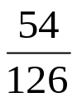

Solve
- 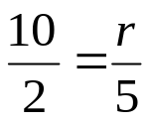



Home Practice

Due Today:
- Assignment #65
- Chapter 4 Cumulative Review

Due 6/12:
- Assignment #66
- Chapter 5 Review

Quiz on Friday!!! 

Agenda

- Warm-Up
- HP Check

- Review: Chapter 5 Operations with Fractions

Class Practice
Home Practice

- Return Graded Work

“It is never too late to be what you might have been.”
- G. Eliot

