Mr. Sabado, Pre-Algebra Week 18 Thursday, June 12, 2014

Warm-Up

1. Solve
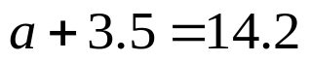

Simplify the following
2. 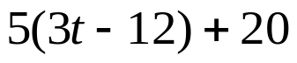



Home Practice

Due Today:
- Assignment #66
- Chapter 5 Review

Due 6/13:
- Assignment #67
- Chapter 1-5 Review
HW: Even #,
EC: Odd #

Quiz on Friday!!! 

Agenda

- Warm-Up
- HP Check

- Review: Chapters 1-5

Class Practice
Home Practice

- Return Graded Work

“It is never too late to be what you might have been.”
- G. Eliot

