Mr. Sabado, Pre-Algebra Week 18 Friday, June 13, 2014

Warm-Up

Evaluate the following

- 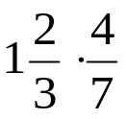

- 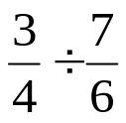



Home Practice

Due Today:
- Assignment #67
- Chapter 1-5 Review
HW: Even #,
EC: Odd #

Due 6/15:
Quiet Activity

Quiz Today!!!


Agenda

- Warm-Up
- Turn in Opener Packet

- Quiz: Chapters 1-5

Quiet Activity

- Return Graded Work

“It is never too late to be what you might have been.”
- G. Eliot

