Mr. Sabado, Pre-Algebra Week 19 Monday, June 16, 2014

Warm-Up

Simplify
- 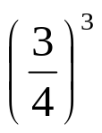

- 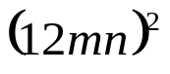



Home Practice

Due Today:

Quiet Activity

Due 6/17:
- Assignment #68
- Chapter 6 Review

Quiz on Wednesday!!!


Agenda

- Last Opener Sheet
- Warm-Up

- Finals Review: Chapters 6

- Class Practice

- Home Practice

- Return Graded Work

“It is never too late to be what you might have been.”
- G. Eliot

