Mr. Sabado, Pre-Algebra Week 19 Tuesday, June 17, 2014

Warm-Up

- What is 25% of 32?

- Solve the Following proportion.
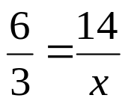



Home Practice

Due Today:
- Assignment #68
- Chapter 6 Review

Due 6/18:
- Assignment #69
- Chapter 7 Review

Quiz on Wednesday!!!


Agenda

- Warm-Up
- HP Check

- Finals Review: Chapter 7

- Class Practice

- Home Practice

- Return Graded Work

“It is never too late to be what you might have been.”
- G. Eliot

