Mr. Sabado, Pre-Algebra Week 19 Wednesday, June 18, 2014

Warm-Up

Use the following formula to find the slope.
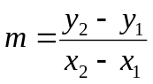
- 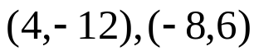

- What is the formula to find the area of a trapezoid?
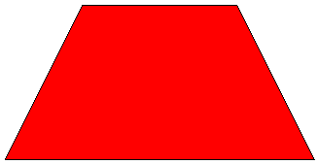



Home Practice

Due Today:
- Assignment #69
- Chapter 7 Review

Due 6/19:
- Assignment #70
- Chapter 8 Review

Quiz Today!!!
Quiz on Friday!!!


Agenda

- Warm-Up
- HP Check

- Finals Review: Quiz - Chapter 7

- Home Practice

- Grade Quiz

- Return Graded Work

“It is never too late to be what you might have been.”
- G. Eliot

