Mr. Sabado, Pre-Algebra Week 17 Monday, June 2, 2014

Warm-Up
- Find the area of the trapezoid.

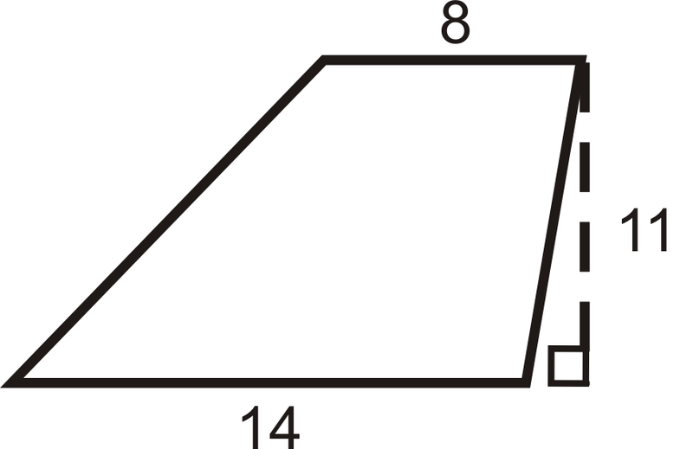



Home Practice

Due Today:
- Extra Credit: 10-2 Enrichment

Due 6/3:
- Assignment #60
- 10.1 -10.3 Review Packet

Quiz on Friday!!!


Agenda

- Pick up Opener Sheet
- Warm-Up

- Class Practice: Brain Teasers: X Marks the Spot/Puzzle #5

- Home Practice

- Return Graded Work

“It is never too late to be what you might have been.”
- G. Eliot

