Mr. Sabado, Pre-Algebra Week 17 Tuesday, June 3, 2014

Warm-Up
Simplify
- 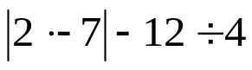

- 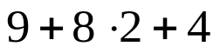



Home Practice

Due Today:
- Assignment #60
- 10.1 -10.3 Review Packet

Due 6/4:
- Assignment #61
- Chapter 1 & 2 Review

Quiz on Friday!!!


Agenda

- Warm-Up
- HP Check

- Guided Class Practice:
- Independent Practice
- Home Practice

- Return Graded Work

“It is never too late to be what you might have been.”
- G. Eliot

