Mr. Sabado, Pre-Algebra Week 17 Wednesday, June 4, 2014

Warm-Up

Simplify the following.
- 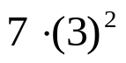

- Use the following formula to find the slope.
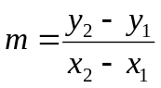
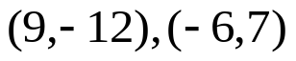



Home Practice

Due Today:
- Assignment #61
- Chapter 1 & 2 Review

Due 6/5:
- Assignment #62
- Chapter 1 & 2 Review Part 2

- Chapter 1 and 2 Review Quiz Thursday!!!

Agenda

- Warm-Up
- HP Check

- Class Practice: Brain Bashers
- Independent Practice

- Return Graded Work

“It is never too late to be what you might have been.”
- G. Eliot

