Mr. Sabado, Pre-Algebra Week 17 Thursday, June 5, 2014

Warm-Up

1. Solve
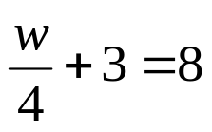

2. Solve
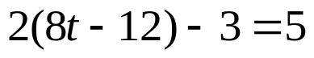



Home Practice

Due Today:
- Assignment #62
- Chapter 1 & 2 Review Part 2

Due 6/6:
- Opener Packet

- Chapter 1 and 2 Review Quiz Thursday!!!

Agenda

- Warm-Up
- HP Check

- Quiz: Chapter 1 and 2 Review

Quiet Activity

Prepare your Opener Packet

- Return Graded Work

“It is never too late to be what you might have been.”
- G. Eliot

