Mr. Sabado, Pre-Algebra Week 17 Friday, June 6, 2014

Warm-Up

1. Solve and graph
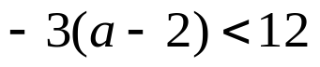
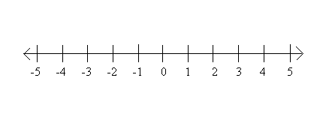

Simplify
2. 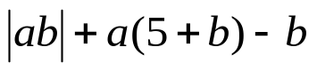
when a = -1, b = 7



Home Practice

Due Today:
- Opener Packet

Due 6/9:
- Assignment #63
- Chapter 3 Review

Agenda

- Warm-Up
- Turn in Opener Packet

- Grade Quiz: Chapter 1 and 2 Review

Class Practice
Home Practice

- Return Graded Work

“It is never too late to be what you might have been.”
- G. Eliot

