Mr. Sabado, Pre-Algebra Week 18 Monday, June 9, 2014

Warm-Up

Determine the mean of the following:
1) 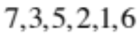

Determine the mode of the following:
2) 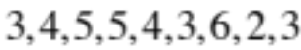


Home Practice

Due Today:
- Assignment #63
- Chapter 3 Review

Due 6/10:
- Assignment #64
- Chapter 3 Cumulative Review

Quiz on Friday!!! 

Agenda

- Pick Up Opener Sheet
- Warm-Up
- HP Check

- Review: Chapter 3 Decimals and Equations

Class Practice
Home Practice

- Return Graded Work

“It is never too late to be what you might have been.”
- G. Eliot

