Mr. Sabado, Algebra 1 Week 14 Monday, December 1, 2014

Homework

Due Today:
- Assignment #52:
- Who Can’t Turn Pancakes?

Due 12/2:
- Assignment #53:
- Spiral Review Worksheet

Quiz Friday!!!


Agenda

- Pick Up Opener Sheet
- Warm-Up

- Review: Solving Equations

- Class Work

- Homework

- Return Graded Work

Warm-Up

Solve each equation

- 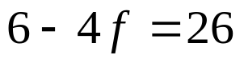

- 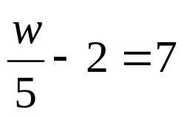

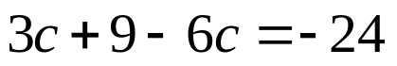

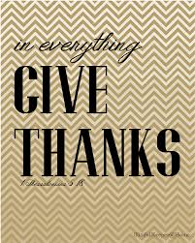
whs.saba.do

“It is never too late to be what you might have been.”
- G. Eliot

