Mr. Sabado, Algebra 1 Week 14 Thursday, December 4, 2014

Homework

Due Today:
- Assignment #55:
- Solving Absolute-Value Equations pg. 57

Due 12/5:
- Assignment #56:
- Quiz Review Worksheet

Quiz Friday!!!


Agenda

- Warm-Up
- HW Questions

- Review: Solving Absolute Value Equations

- Class Work

- Homework

- Return Graded Work

Warm-Up

Solve
- 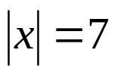

- 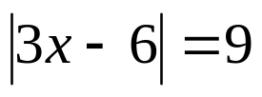

- 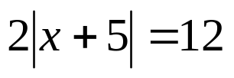


whs.saba.do

“It is never too late to be what you might have been.”
- G. Eliot

