Mr. Sabado, Algebra 1 Week 14 Friday, December 5, 2014

Homework

Due Today:
- Assignment #56:
- Quiz Review Worksheet

Due 12/8:
- Assignment #57:
- Activity 31 Worksheet

Quiz Friday!!!


Agenda

- Warm-Up
- HW Questions
- Turn in Packet

- Quiz: Solving Absolute Value Equations

- Quiet Activity
- Homework

- Return Graded Work

Warm-Up

Solve
- 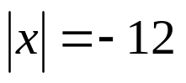

- 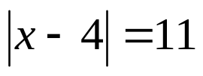

- 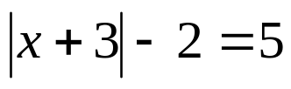

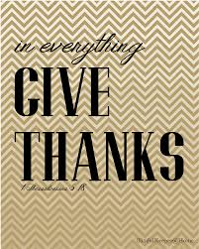
whs.saba.do

“It is never too late to be what you might have been.”
- G. Eliot

