Mr. Sabado, Algebra 2 Week 14 Tuesday, December 2, 2014

Homework

Due Today:
- Assignment #48
Graphing Quadratics Review Worksheet

Due 12/3:
- Assignment #49
p.270 38 and 39
p.298 68 and 70



Agenda

- Warm-Up
- HW Questions

- Lesson: Projectile Motion

- Class Work
- Homework
- Return Graded Work

Warm-Up
Solve using any method.
- 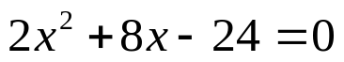
- 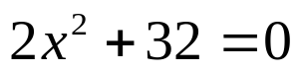

- 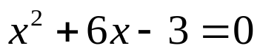
whs.saba.do


“It is never too late to be what you might have been.”
- G. Eliot

