Mr. Sabado, Algebra 1 Week 4 Monday, February 23, 2015

Home Practice

Due Today:
Extra Credit:
This Puzzle is Alarming

Due 2/24:
Assignment #11:
Function Notation review

Quiz Friday!!!


Agenda

- Opener sheet
- Warm-Up

- Return Skills Quiz #3: Function Notation

- Function Tool Box

- Class Work

- Homework

Warm-Up
Simplify the following 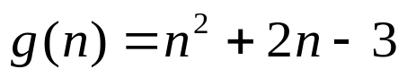
- 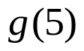
- 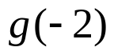
Find the value for n
- 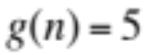
` whs.saba.do


“It is never too late to be what you might have been.”
- G. Eliot

